**Advanced Analytics Techniques:** Apply more complex analysis techniques, such

as machine learning algorithms, time series analysis, or sentiment analysis,

depending on the dataset and objectives.

**Follow the below steps for Advanced Analytics Techniques:**

**NOTE:** We are going to use the Machine Learning Algorithm like K Means

Clustering Algorithm for analysis.

**Step 1 –** Import the necessary libraries and the dataset in Jupyter Notebook.

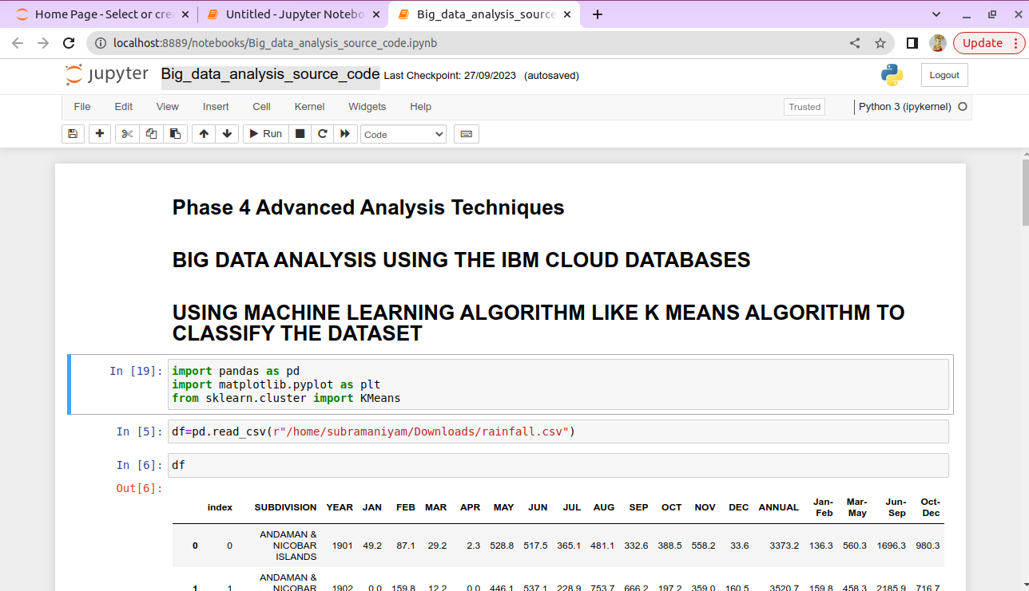

**Step 2 –** Clean and remove the noisy data in the dataset using python script.

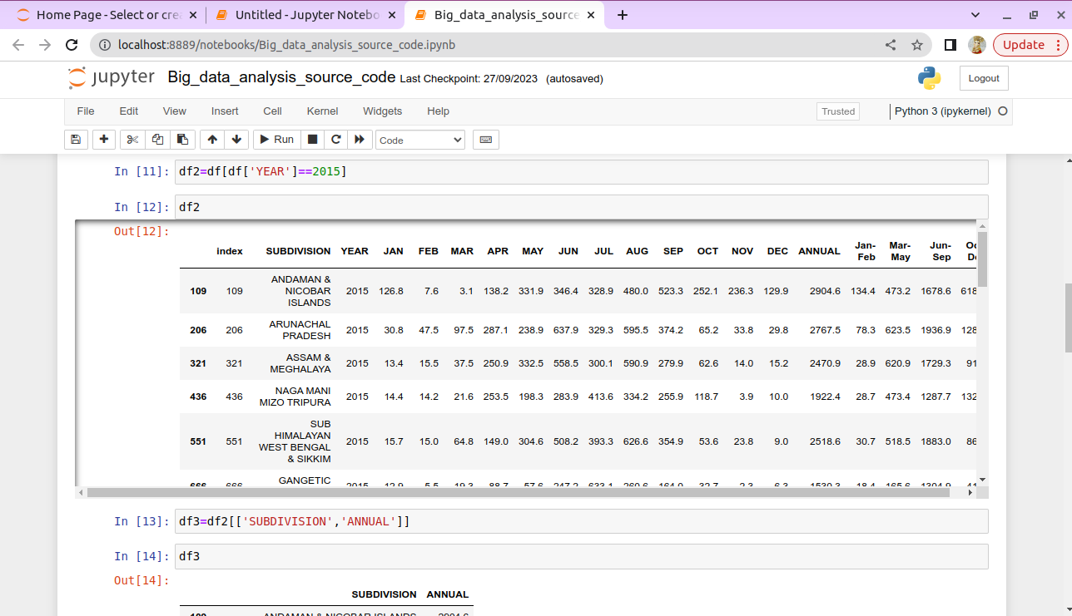

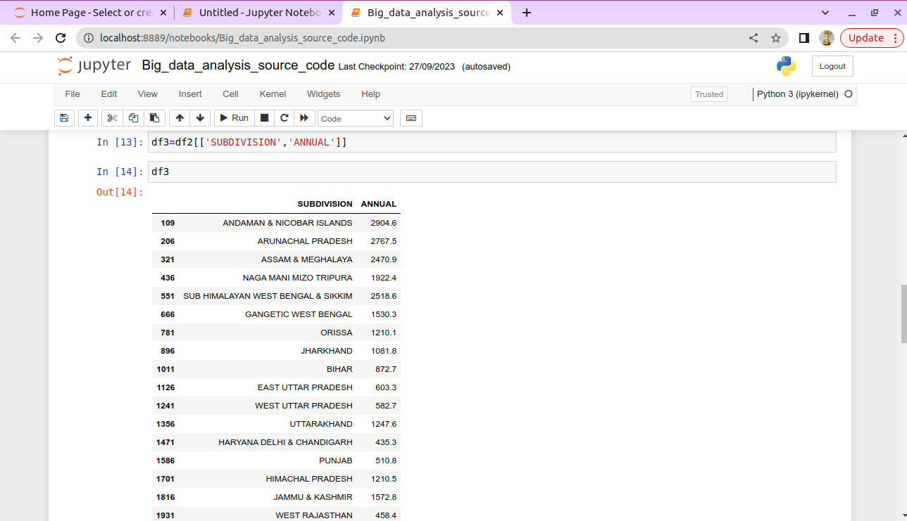

**Step 3 –** Store the necessary values into the empty array for plotting purpose.

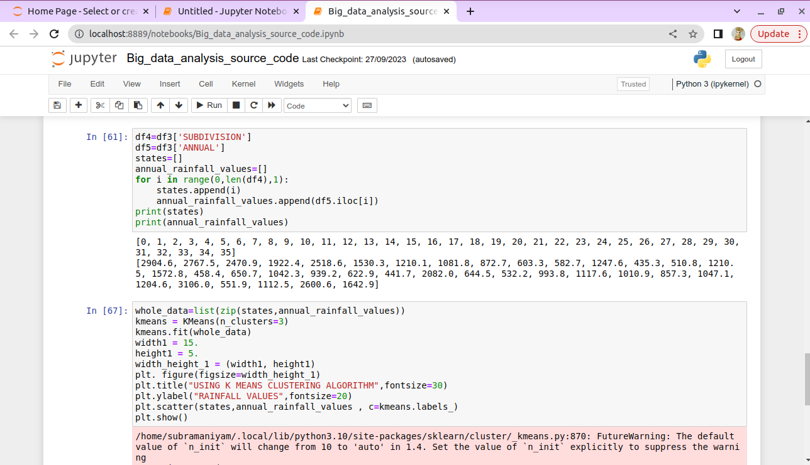

**Step 4 –** After storing the values in array using K Means Clustering Algorithm to plot the graph and analyze the results.

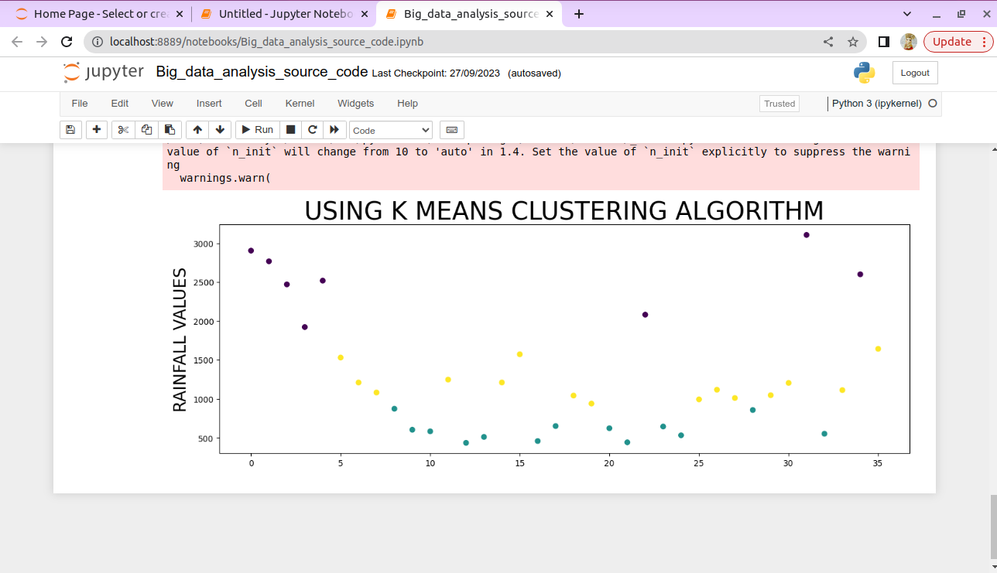

**Visualization:** Create visualizations to showcase the analysis results. Use tools

like Matplotlib, Plotly, or IBM Watson Studio for creating graphs and charts.

**Follow the below steps for Advanced Analytics Techniques:**

**NOTE:** We are going to use the IBM Watson Studio for creating graphs and charts.

Step 1 – Open our cloud account and create the IBM Watson Studio then go to the

Resource Poll and click Artificial Intelligence and Machine Learning and choose

IBM Watson Studio.

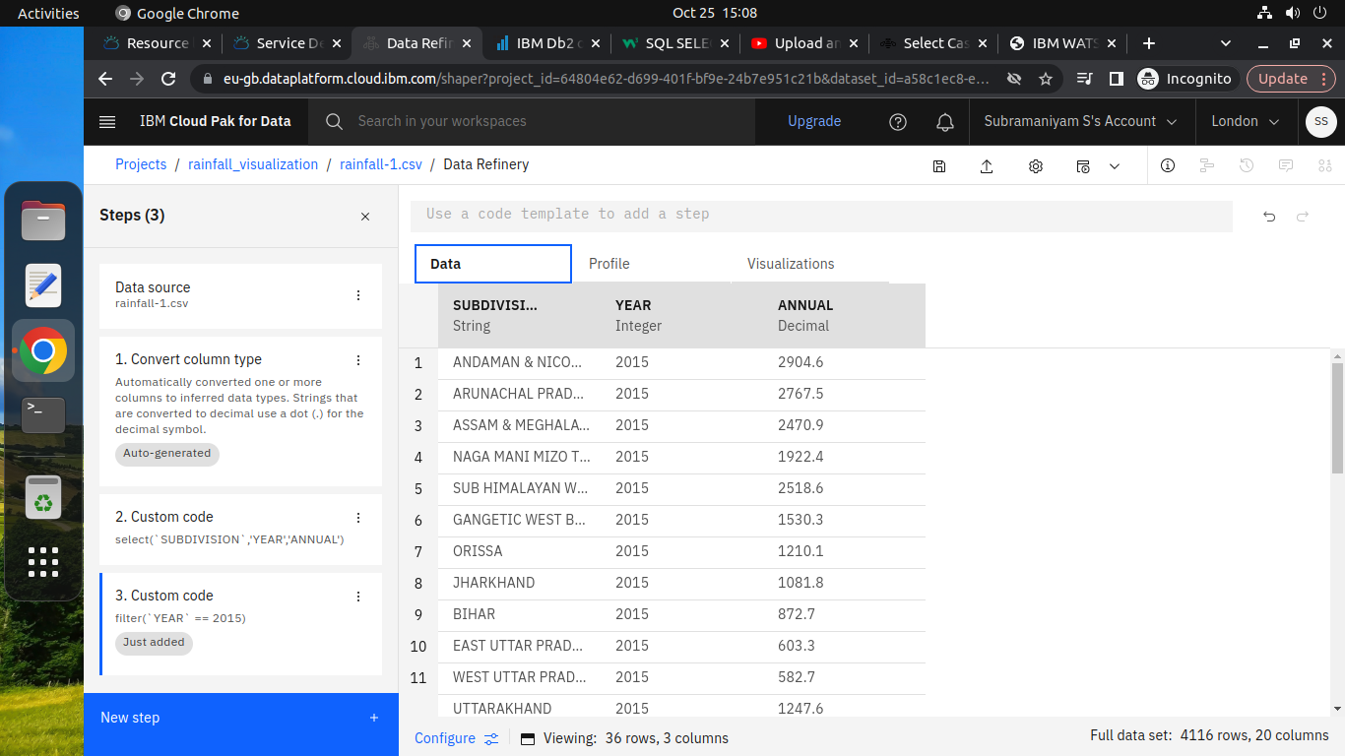

Step 2 – Load the Dataset and put some queries to refine the data for our visualization.

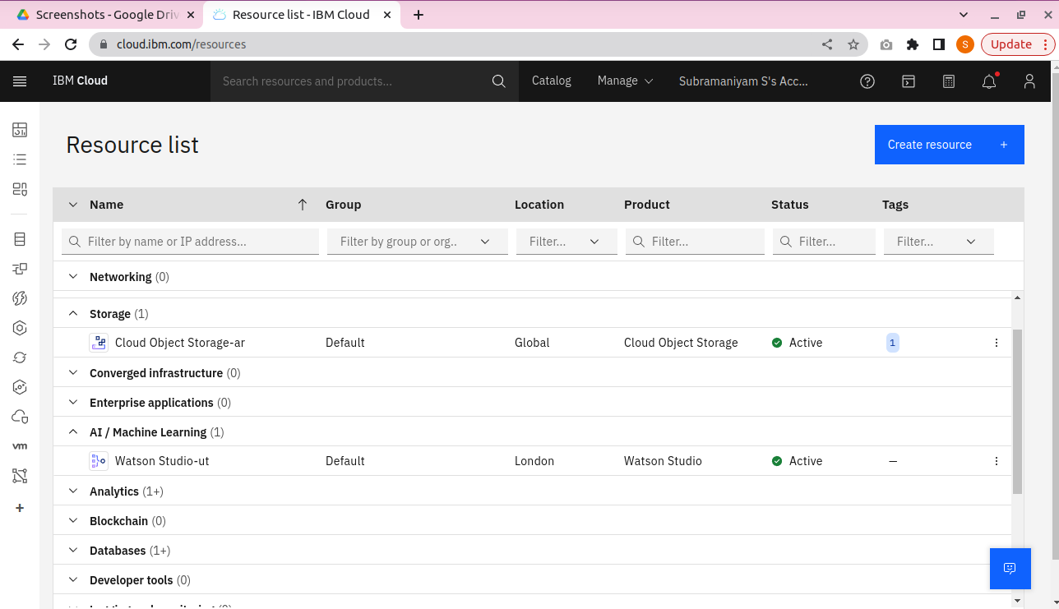

Step 3 – Finally, using the refine script to perform the visualization.

